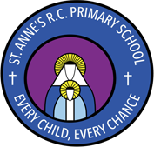

Handwriting Policy

Intent
Handwriting is a skill which, like reading and spelling, affects written communication across the curriculum. Children must be able to write with ease, speed and legibility. Cursive handwriting teaches pupils to join letters and words as a series of flowing movements and patterns. The development of this fluid style when mastered allows children to apply their energy into the content of their writing as opposed to the formation of the letters themselves. Handwriting skills are taught regularly and systematically throughout the school.
At St Anne’s RC Primary School our aims in teaching handwriting are:
- To enable children to write in a consistent, well presented and legible format.
- To have a consistent approach across Foundation Stage, Key Stage 1 and 2 when teaching handwriting.
- To ensure that from the Summer Term of Year 1 to the end of Year 6 children are using a cursive writing style.
- To make sure all children know the difference between lower and upper case letters.
- To ensure the skills taught at Key Stage 1 continue to develop throughout Key Stage 2.
- To adopt a consistent approach towards handwriting by all adults when writing in children’s books, on the whiteboard or on displays / resources.

Implementation
Children will be taught to:
- Hold a pencil correctly
Children should be encouraged to use a tripod pencil grip, where the pencil is gripped between the index finger and the thumb. The middle finger is then used to support the underside of the pencil as shown below.

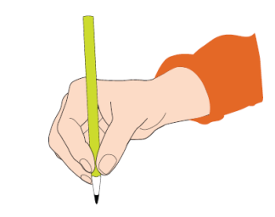
- Adopt the correct posture when writing
Children should be encouraged to adopt the correct writing position as shown below:

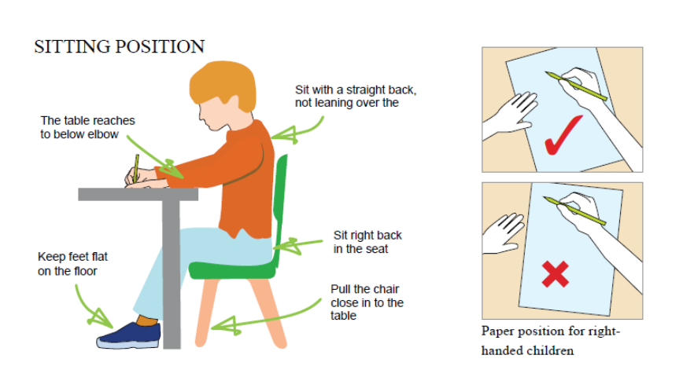

(Children who are left-handed should reposition the paper the other way and sit to the left -hand side if seated next to a right handed child).
- Write from left to right and from top to bottom of the page
- Start and finish letters correctly in a cursive style (from the Autumn Term of year 1 onwards)
- Form regularly sized and shaped letters
- Use regular spacing between letters and words
- Take a pride in their written work and the overall presentation.
- The cursive script agreed at St Anne’s RC Primary School is shown below:
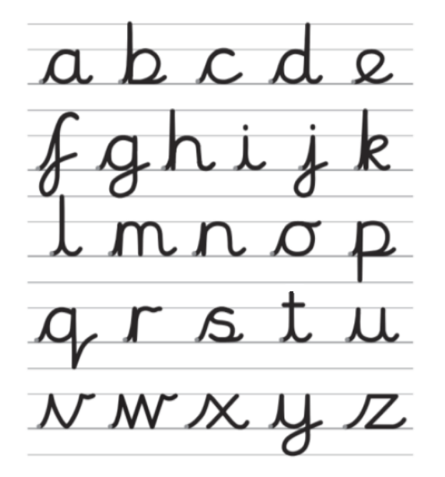
In Nursery children will be encouraged to develop gross motor control through the use of large equipment for mark making such as big chalks, paint brushes, finger paints, shaving foam etc. They will develop their fine motor skills and use a range of mark making tools such as pencils, pens and crayons. They will be encouraged to talk about shapes and movement. They will practise the main handwriting movements for…
In Reception children letter formation is taught alongside phonic development. Our aim is that by the end of foundation stage all children hold a pencil correctly and form all letters and numbers correctly. Errors in pencil grip and letter formation will be immediately addressed, modelled and corrected.
Initially foundation children will use unlined paper as the focus is correct formation rather than size or positioning.
In Key Stage 1 all children should receive a daily handwriting session for approximately 10-15 mins. (This may be as part of a literacy/phonics lesson).
In Year 1. During the Autumn Term cursive handwriting will be introduced starting with beginning each letter from the line and going up individually before then moving on to joining them together to form words. Handwriting can also be linked to phonic development with the introduction of new sounds written in a cursive style during phonics lessons. Our aim is that by the end of Year One children will be forming all letters correctly and joining in a cursive script.
In Year 2 adults will model cursive writing from the beginning of the year. The children will be encouraged to continue the development of basic joins which they should transfer into all their independent writing. They will also continue to link their handwriting to their phonic development as they learn to write new sounds using a cursive writing style.
In Key Stage 2 all children should receive a daily handwriting session for a minimum of 10 mins.
In Year 3 children will continue to develop their use of cursive handwriting building upon the skills they have developed in Key stage 1.
In Years 4, 5 and 6 children will be expected to use cursive handwriting in all areas of the curriculum. Those children whose writing is neat and legible may be encouraged to use handwriting pens by the end of Year 6.
If any child is not on track to reach these expectations, they will receive additional support through small group intervention groups.
Handwriting Equipment
Children will use line sizes appropriate to their stage in writing. Children will also practise using the use the same sized lines as their other curricula books so that children’s skills are transferable and that the same expectation of handwriting in set across all writing.
Children should use a sharp HB pencil for all handwriting initially. When in KS2 teachers assess that children are competent at joined handwriting they should be allowed to use a black handwriting pen. (No biro type pens will be used.)
In some cases, depending on the specific needs of individual, children may use pencil grips or pens with a specific grip.

Assessment
A uniformed handwriting style should be consistent throughout the school; this will be evident on display boards and monitored through lesson observations and book scrutiny.

Marking and Feedback
We emphasise constructive feedback. In our feedback policy we have clear systems for feedback of children’s work which is adhered to throughout our handwriting sessions. In handwriting sessions and during independent work it is important that incorrect pencil grip and incorrect letter formation are identified and corrected at the point it occurs. Children use our ‘Writing Non-negotiables’, which includes references to the expectations of handwriting to ensure that their work meets expectations.

Impact
Handwriting is a skill which affects written communication across the curriculum. Our aim is that children are able to write with ease, speed and legibility.
By year 6 children will use cursive handwriting using flowing movements and patterns. This handwriting should be demonstrated in all writing across the curriculum. Writing should be fluid in style to allow children to apply their energy into the content of their writing as opposed to the formation of the letters themselves.

Policy Written by: A.Shore
Policy Reviewed: Nov 2023
Date to be reviewed: Nov 2024

