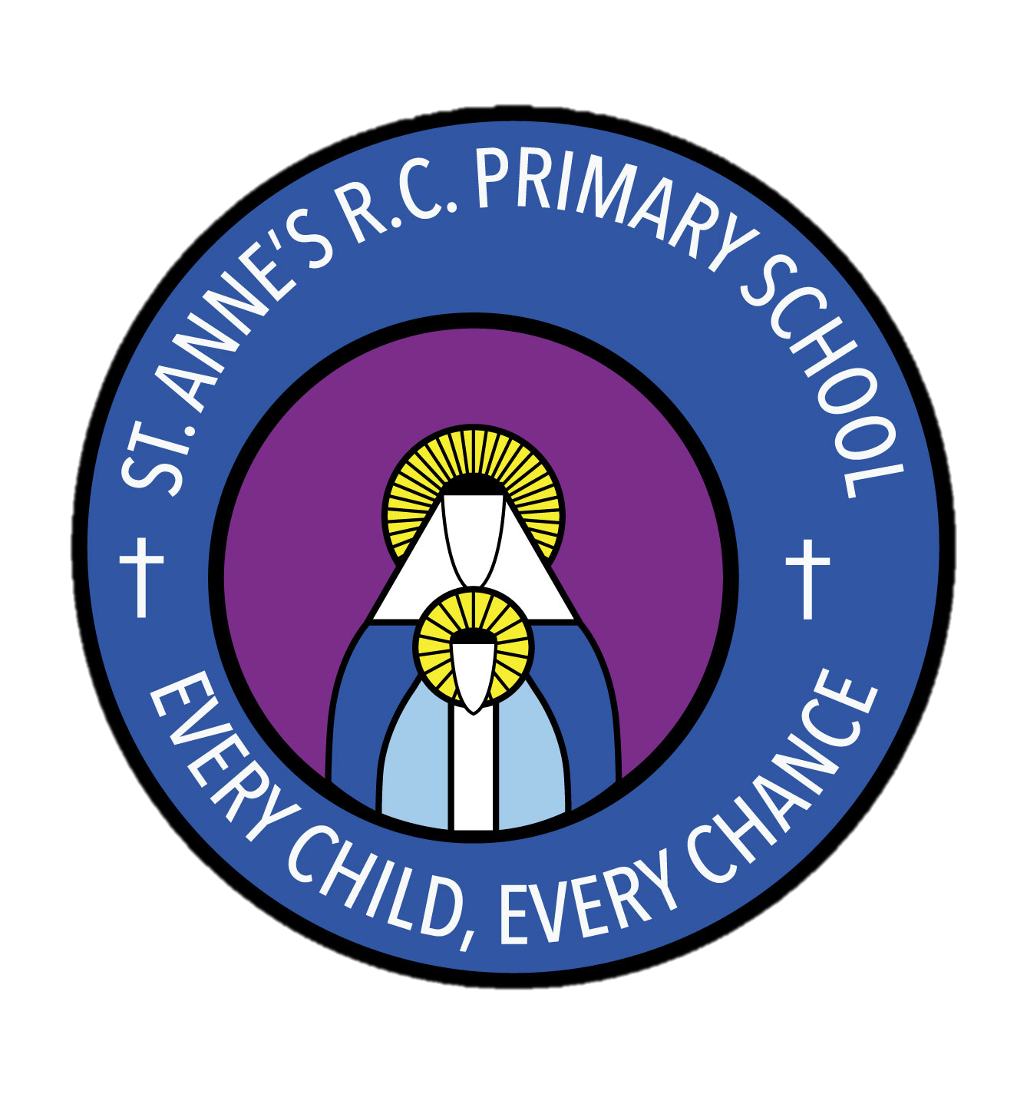

St Anne’s RC Primary School

What a unit looks like
PSHE

Unit overview of PSHE Association Scheme of Work:
For key stage 1 and 2 there are three modules that teaching staff will deliver throughout the year. Within these modules, there will be three units which organise the learning into smaller themes. The year begins with ‘Relationships’, which has links to our RE modules. While we follow a thematic scheme of work, the modules can be delivered in differing orders to ensure the best and most effective learning experience for the children in our care. This also allows the opportunity for cross curricular learning alongside our PSHE/SMSC calendar.

Relationships |  |  | Living in the wider world |  |  | Health and Wellbeing
Families and friendships | Safe relationships | Respecting ourselves and others | Belonging to a community | Media literacy and digital resilience | Money and work | Physical health and  Mental wellbeing | Growing and changing | Keeping safe

How PSHE is taught in our school:

In the EYFS PSHE is taught through a story or text relating to the topic for that half term. For example, a topic on ‘Under the Sea’ may have a focus on a book such as ‘The Rainbow Fish’ where the theme of friendship could be discussed and explored, with the children being able to relate to, and reflect upon the book that they have become familiar with. Similarly, a topic on people who help us could focus on the health and safety aspect of PSHE, where the children can draw upon their ever expanding knowledge. Using a book as a starting point, children are introduced to a theme and are able to discuss and explore this. Children with participate in an activity to extend this learning. PSHE is assessed by staff using the statutory Early Learning Goals and the non-statutory development matters statements, which are broken down into ages 0-3, 3-4, Reception and ELGs.

In both KS1 and KS2, children will begin a unit of PSHE using a text or photo as a starting point. They will use this to generate a discussion before introducing the learning objectives for the unit. Children will then partake in an activity such as drama, discussion or a written task to explore this theme and deepen their understanding. Children will be given the opportunity to ask questions and address misconceptions.

Children will also take part in whole school themed days and weeks as set out in our PSHE and SMSC calendar, for example road safety week, water safety week, anti-bullying etc.
Learning activity examples:
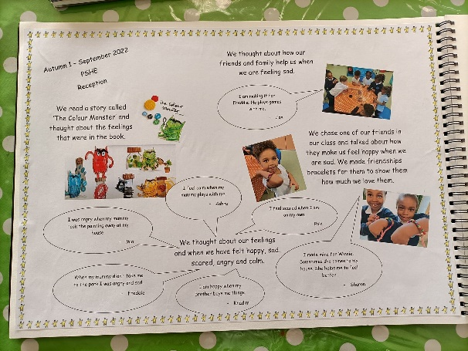
Each class has a PSHE scrapbook which follows them throughout their school life. Each half term classes will complete 1 page to show their learning for that half term.

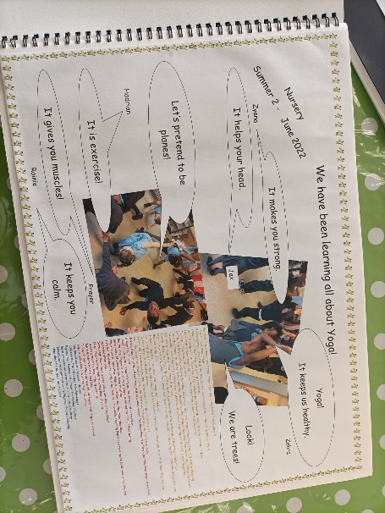

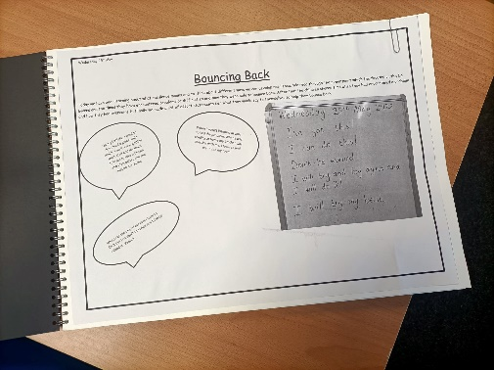

The modules and units from the PSHE Association will allow a spiral curriculum, with the children building upon their prior learning to deepen their understanding and develop their taught skills.
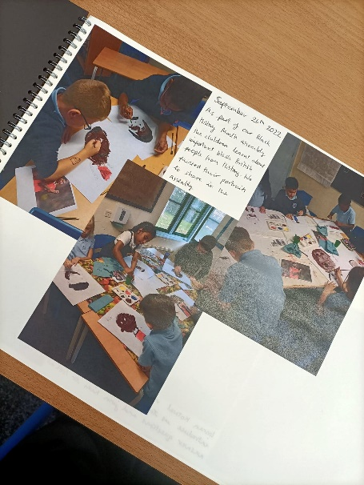

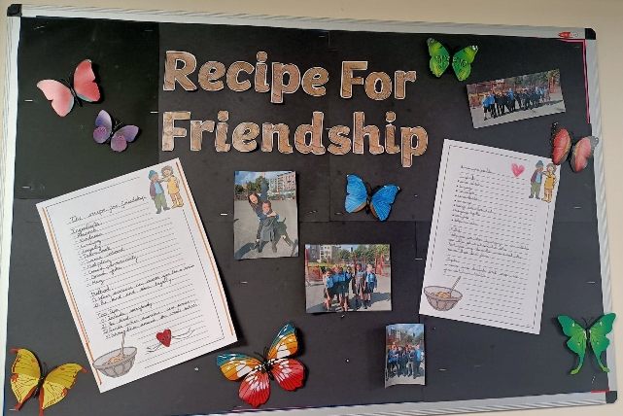
Children will learn through drama, art, discussion and written tasks to ensure all children have the opportunity to access the curriculum. Evidence of this learning will be included within the scrapbook and on displays.

Assessment:

Teachers will assess the children’s learning each term using their judgement. The scrapbook contains all of the learning objectives for PSHE from EYFS to the end of KS2 using the development matters and ELGs and the PSHE Association learning outcomes. Each of these documents have the space for teachers to insert a date that they have been covered by a PSHE unit.

Children’s learning and knowledge will be assessed as working towards, working at and working above ARE.

