Nursery Homework

w/b 23/5/22

Can you practice your numbers some more? Can you try and write them using the rhymes to help you remember?

You could do some counting and adding and even some take away number sentences, like we have been doing this week. Remember the signs using your arms to help you!

[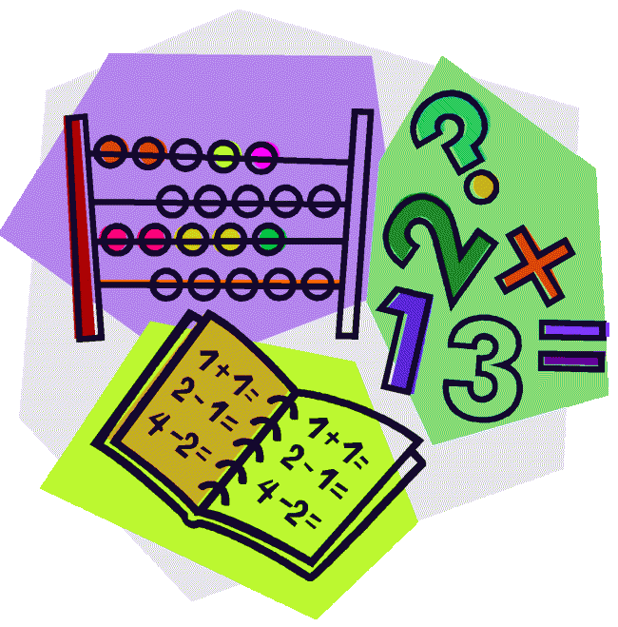](http://cheetahclass.files.wordpress.com/2013/11/numeracy.gif)

While we are on our break, could you practice writing your name some more? You could even try to write your second name! I’ve put a letter formation sheet on the back of your homework to help you. Does your name have any ascenders or descenders in it?

Remember; ascenders go up, up, up to the sky and descenders go down, down, down under the line!

[](http://www.google.co.uk/url?sa=i&rct=j&q=&esrc=s&source=images&cd=&cad=rja&uact=8&docid=M5gmXQrAanB0dM&tbnid=JEtC_hATHEZr4M:&ved=0CAcQjRw&url=http://imgkid.com/someone-writing-clipart.shtml&ei=sG0YVMnmOYnvOpPUgcAD&psig=AFQjCNF_aceEKKd8KQ0wJA7ZrSEZCrIOFw&ust=1410973404907077)



Don’t forget to follow us on Twitter! Find us @StAnnesAncoats

Our class email address is [nursery@st-annes-pri.manchester.sch.uk](mailto:nursery@st-annes-pri.manchester.sch.uk).

Thank you for your continued support.

Remember to read your book with your grown up! Can you talk about the pictures? Can you guess what will happen next? Can you find the sound that is at the beginning of your

name? What was your favourite part? Please bring your books back on **Wednesday to be** changed and returned on Friday.

This week our Nursery Star of the Week is…

Jax!

Jax has had a fantastic week this week. He amazed us with his take away number sentences and his amazing work on worms. He remembered all of the colours for the Union Jack flag and made some wonderful decorations for the Queen’s Platinum Jubilee. He has also been a wonderful friend and been looking after his peers this week. We are super proud of him! Well done Jax!



We want you to have an amazing break and have lots of fun! Enjoy celebrating the Queen’s Platinum Jubilee and make some memories with your family and friends. You could make a pinwheel and stick it on a stick or a straw and watch it blow in the wind.

Send some photos or a short video clip to us at [nursery@st-annes-pri.manchester.sch.uk](mailto:nursery@st-annes-pri.manchester.sch.uk) with your child’s name and the date as the subject.

