Nursery Homework

w/b 9/5/22

In our maths sessions this week we have been looking at writing our numbers. We used our special rhymes to help us remember how to write them. Can you practise your numbers at home? You could write them using your magic writing finger, using chalk on the floor outside, using pencils or colours… The possibilities are endless!

We’d love to see some photos! Send them in to our usual email address.

[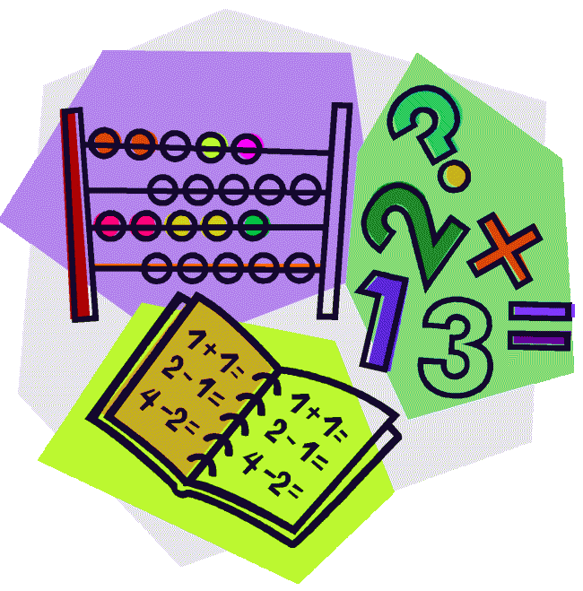](http://cheetahclass.files.wordpress.com/2013/11/numeracy.gif)

This week we have been looking more at ‘Aaarrrggghhh Spider!’ We thought about how the book was a made up story and found out that they have a special name; fiction books! We then looked at some real life information books that weren’t made up at all and found out that they have a name too; non fiction! Do you have any fiction and non fiction books at home? Can you have a look at them with a grown up? Remember – fiction books are made up stories, and non fiction are real life and true.

[](http://www.google.co.uk/url?sa=i&rct=j&q=&esrc=s&source=images&cd=&cad=rja&uact=8&docid=M5gmXQrAanB0dM&tbnid=JEtC_hATHEZr4M:&ved=0CAcQjRw&url=http://imgkid.com/someone-writing-clipart.shtml&ei=sG0YVMnmOYnvOpPUgcAD&psig=AFQjCNF_aceEKKd8KQ0wJA7ZrSEZCrIOFw&ust=1410973404907077)



Don’t forget to follow us on Twitter! Find us @StAnnesAncoats

Our class email address is [nursery@st-annes-pri.manchester.sch.uk](mailto:nursery@st-annes-pri.manchester.sch.uk).

Thank you for your continued support.

Remember to read your book with your grown up! Can you talk about the pictures? Can you guess what will happen next? Can you find the sound that is at the beginning of your

name? What was your favourite part? Please bring your books back on **Wednesday to be** changed and returned on Friday.

This week our Nursery Star of the Week is…

Hadrian!

Hadrian has had a fantastic week this week. His fact writing was like a Year 6 child, and his work in the number area was incredible! He made a brilliant minibeast mask and chose his own equipment and he has been doing some fantastic music, keeping the beat. He has also been a great friend. Well done Hadrian!



This week is mental health awareness week. We have been thinking lots about what makes us feel worried or nervous and what could make us feel better. We thought about how keeping our minds healthy was just as important as keeping our bodies healthy. What could you do at home this week to make you feel happy?

Send some photos or a short video clip to us at [nursery@st-annes-pri.manchester.sch.uk](mailto:nursery@st-annes-pri.manchester.sch.uk) with your child’s name and the date as the subject.

