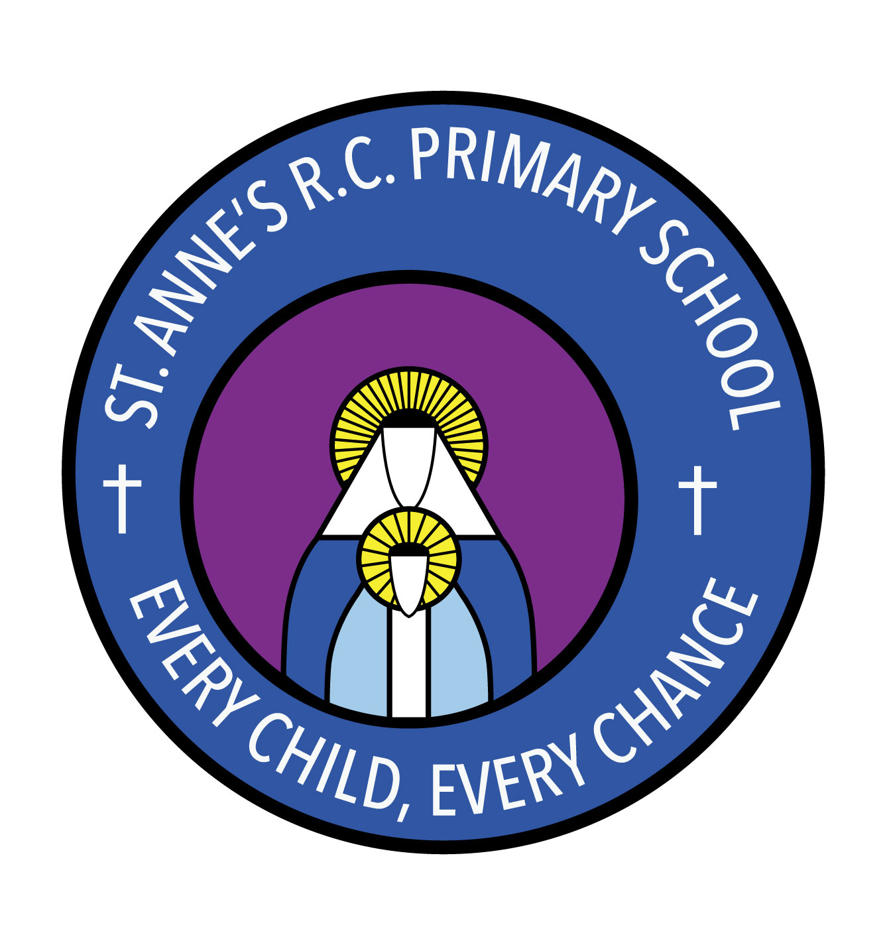
St Anne’s RC Primary School
Carruthers Street, Ancoats,
Manchester, M4 7EQ

Headteacher: Mrs A Shore
Deputy Head: Mrs J Greene

Dear Parents/Carers,

Welcome back! We hope you had a good break and enjoyed some time together.

This half term our topic will be ‘Minibeasts,’ where we will we be learning all about minibeasts and bugs. Our books will be ‘The Very Hungry Caterpillar’, ‘Aaarrrggghhh Spider!’ and ‘Yucky Worms.’

In maths we will be continuing to work on our numbers and counting, and matching numerals to quantities. We will also be working some more on addition and subtraction.

In RE our first big question will be, ‘What is good news?’ where we will be looking at what we think ‘good news’ might be and why this is important.

In PSHE we will be thinking about how to keep our bodies healthy and why this is important.

In music our topic is, ‘Moving patterns’ where we learn more about making music using different sound makers. We will also be hosting our own ‘Ugly Bug Ball.’

In PE this half term we will continue to work on our gross and fine motor skills using large and small scale movements.

If you have any questions or queries, please don’t hesitate to speak to a member of staff who will be happy to make an appointment.

Thank you for your continued support,

Mrs C Mirza, Mr Arnold and Mrs Suleman

