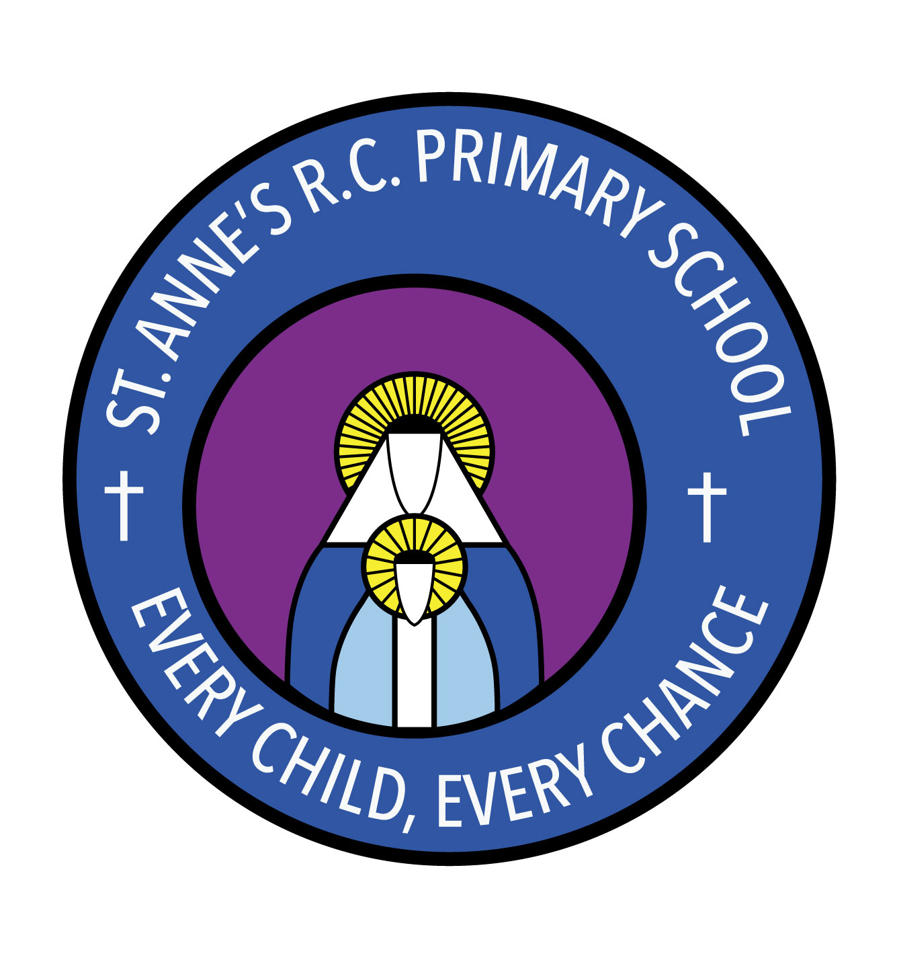
St Anne’s RC Primary School
Carruthers Street, Ancoats,
Manchester, M4 7EQ

Headteacher: Mrs A Shore
Deputy Head: Mrs J Greene

29/06/21

SACRAMENT OF RECONCILIATION – IMPORTANT MESSAGE

Dear Parent/Guardian,

As you are aware we have had to close school this week for two days and some classes are isolating until next week.

This means that the Sacrament of Reconciliation will take place next Tuesday 6th July at 10am and not Thursday 1st July.

If your child is not due back at school until Wednesday 7th July they will be able to make their First Confession on that day before their First Holy Communion on Thursday 8th July.

I apologise for any inconvenience caused and thank you for your ongoing support.

If you have any questions please do not hesitate to contact me.

Yours sincerely,

Mrs J Greene

