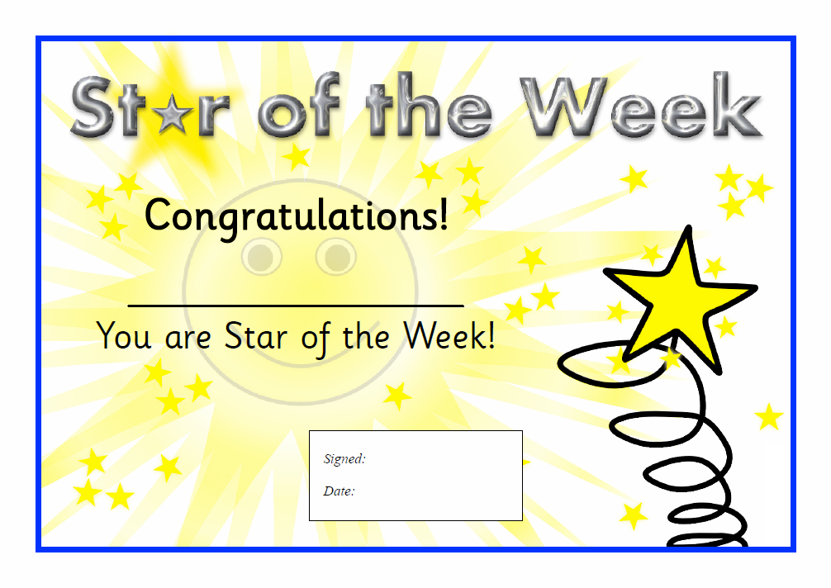

Mrs Corcoran and Mrs Di Rosa

**\*** ☺ Adam ☺ **\***

22nd January 2021