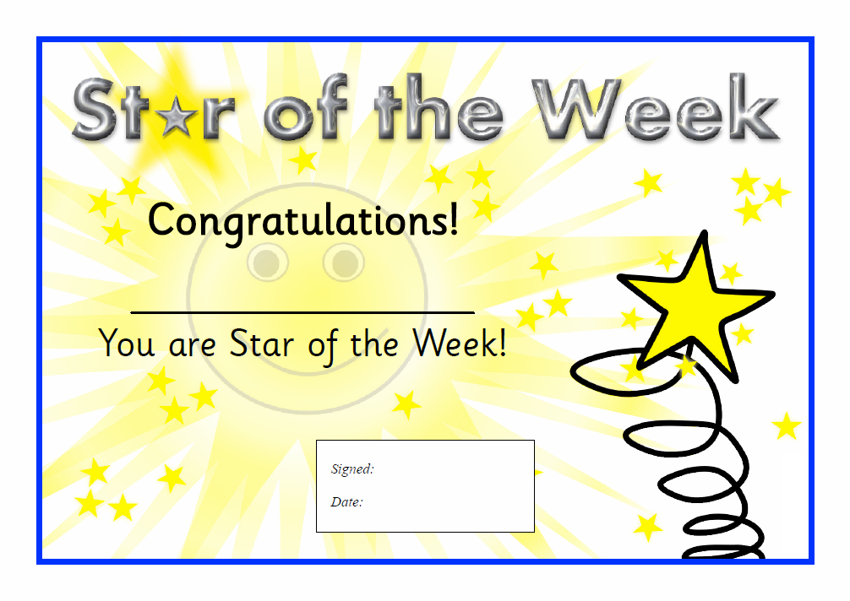

Mrs Corcoran and Mrs Di Rosa

**\*** ☺ Samuel Praise ☺ **\***

14th January 2021