Homework 3/12/20
Due 7/12/20
Spellings for test 10/12:  suggest  digest  congestion  gesture  gestation  lightning  daylight  enlighten  twilight  limelight  Use each of your spellings in a sentence | Literacy  Answer the reading comprehension questions on the sheet.
Times Tables
Make sure you are working on your times tables regularly at home.

Answers
Answers for homework can be found on the Year 6 class page on the school website.
Maths
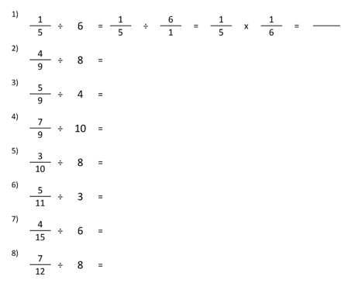

Homework 3/12/20
Due 7/12/20
Spellings for test 10/12:  though  although  thought  through  fought  Use each of your spellings in a sentence | Literacy  Answer the reading comprehension questions on the sheet.
Times Tables
Make sure you are working on your times tables regularly at home.

Answers
Answers for homework can be found on the Year 6 class page on the school website.
Maths

Homework 3/12/20
Due 7/12/20
Spellings for test 10/12:  flies  tries  replies  copies  babies  carries  cries  dries  marries  families  Use each of your spellings in a sentence | Literacy  Answer the reading comprehension questions on the sheet.
Times Tables
Make sure you are working on your times tables regularly at home.

Maths

