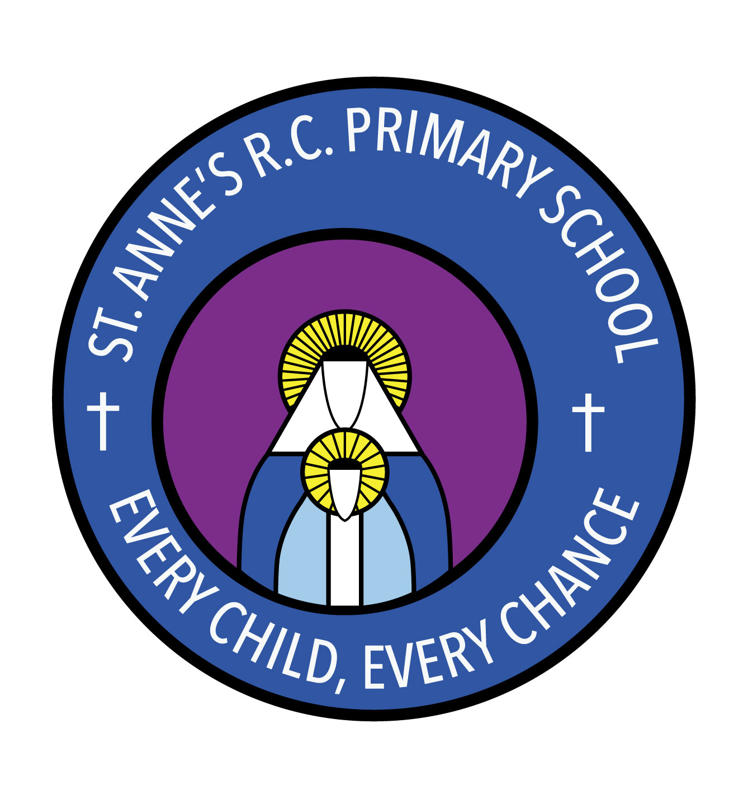
St Anne’s RC Primary School
Carruthers Street, Ancoats,
Manchester, M4 7EQ

Headteacher: Mrs A Shore
Deputy Head: Mrs J Greene

Dear Parents and Carers,

As a part of your child’s education at St Anne’s Primary school, we promote personal wellbeing and development through a comprehensive Personal, Social, Health and Economic (PSHE) education programme. PSHE education is the curriculum subject that gives children the knowledge, understanding, attitudes and practical skills to live safe, healthy, productive lives and meet their full potential. I am writing to let you know that this year we will be implementing the new statutory relationships and sex education (RSE) aspect of this programme. Lessons will include pupils learning about healthy relationships including friendships; families; growing and changing, including puberty; personal hygiene; changing feelings; becoming more independent; keeping safe and developing self-esteem and confidence. Pupils will also have opportunities to ask any questions they may have.

PSHE education is taught throughout the school in every year group and is monitored and reviewed regularly by the staff and governing body. Please visit the school’s website for more detail about our PSHE curriculum. All PSHE teaching will take place in a safe learning environment and is underpinned by our school ethos and values.

As a school community, we are committed to working in partnership with parents. If you would like to find out more or discuss any concerns that you may have, please do not hesitate to get in touch and an appointment can be made.

Thank you for your continued support,

Mrs Shore Mrs Mirza

Headteacher PSHE lead

