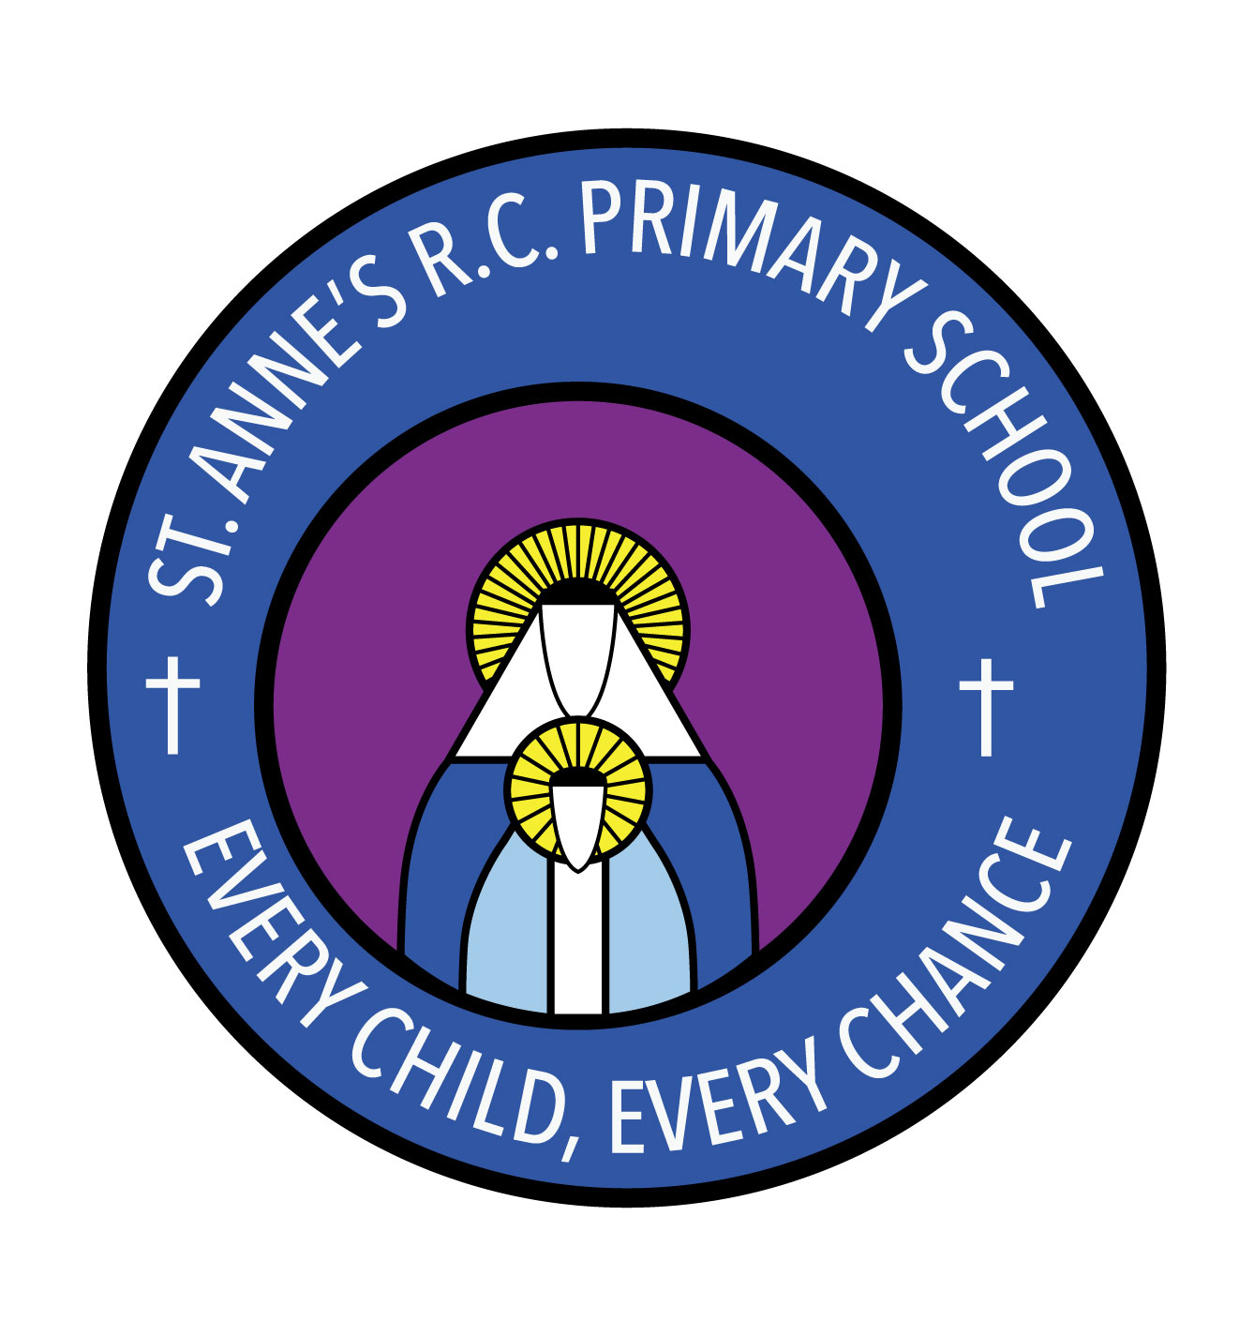
St Anne’s RC Primary School
Carruthers Street, Ancoats,
Manchester, M4 7EQ

Headteacher: Mrs A Shore
Deputy Head: Mrs J Greene

Dear Parents/Carers,

Welcome to Reception! We know how trying last year was for you and your families and we have worked hard to ensure a smooth return to school for all involved. We hope you have all had a fun-filled summer holiday and are looking forward to the forthcoming academic year as much as we are. We wanted to take this opportunity to welcome you back and give you some information about the year ahead.

In Reception, children are able to make use of the outside area each day. Could we please ask that you ensure that your child has weather appropriate clothes? Could we also ask that you write your child’s name in their school uniforms to ensure that they are easily identifiable?

Due to the current situation, your child will not be given a reading book to read with you at home. Instead we will direct you to useful websites where you can find e-books to support your child’s reading.

Homework will be sent home each Thursday and will consist of literacy and phonics, maths and topic work to consolidate the learning from that week. The homework can be emailed in to us at reception@st-annes-pri.mancheser.sch.uk. You can also follow us on Twitter @StAnnesAncoats where we will post updates of our learning.

Each half term we will be learning about a different topic. This half term our topics will be, ‘All About Me’ and ‘Manchester’, where we will we be learning all about ourselves, our families and our city. For each topic we will ask that children take part in a project with you at home. This half term we would ask that you create a family tree at home. You can then take a photograph of it and send it to us at the email address above. This can be done in any way you wish; it’s completely up to you!

In maths we will be working on numbers, matching number to quantity and thinking about more and less. We will also be sorting using different criteria and order by size.

In RE our big question will be, ‘Why am I precious?’ We will be thinking lots about what makes ourselves so special to the people in our families and also to God.

In PSHE we will be thinking about how we are all different and how we can celebrate these differences. We will also be learning about our families and exploring our feelings.

In music our topic is ‘Our Senses’. This unit will allow children to explore their own ideas about music and movement and share their thoughts with others.

In PE this half term we are going to be thinking about fundamental skills. We will be doing some of our sessions outside and would appreciate it if you could bring your child into school wearing their kit on their PE days. PE kit consists of black shorts, white t-shirt and trainers. Our 2 week PE timetable is attached to this letter.

Please ensure that your contact details and medical forms are up to date with the office and that we have signed permission slips for your child to be featured on our website and/or twitter.

If you have any questions or queries, please do not hesitate to speak to a member of staff who will be happy to make an appointment.

We can’t wait to get started!

Thank you for your continued support,

Mrs Mirza and Miss Muldoon.

PE timetable:

Week 1 – Wednesday and Thursday
Week 2 – Monday and Wednesday

