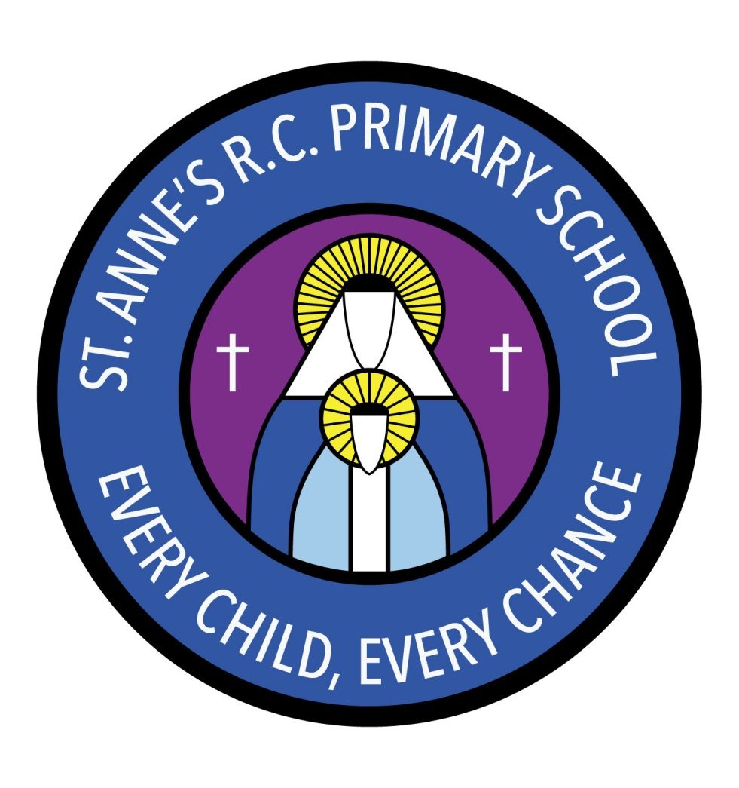
St Anne’s RC Primary School
Carruthers Street, Ancoats,
Manchester, M4 7EQ

Headteacher: Mrs A Shore
Deputy Head: Mrs J Greene

Dear Parents/Carers,
Welcome to Nursery! We have enjoyed getting to know the children and are looking forward to working with you to ensure the best for your child. We would like to give you some information about the year ahead.
As the children do a lot of their learning outside please can you ensure they have weather appropriate clothes. It would be great if your child had a pair of wellies.
It is imperative that your child has a change of clothes in a bag on their peg. They will need a few skirts/trousers, a top, a few pairs of socks, a pair of shoes and a few pairs of underpants/knickers. If they do not have a change of clothing it may result in us having to phone you and for you to bring them down for us so we can change your child.
Please label everything! If your child loses an item that is not named it is so much more difficult to get it back.
Due to the current situation your child will not be given a reading book to read with you at home. Instead we will direct you to useful websites where you can find e-books to support your child’s reading.
Homework will be sent home each Thursday and will consist of literacy and phonics, maths and topic work to consolidate the learning from that week. The homework can be emailed in to us at nursery@st-annes-pri.manchester.sch.uk
Each half term we will be learning about a different topic. Our topic this half term is ‘All About Me’ and ‘Manchester’ where we will be learning all about ourselves, our families and our city.
In maths we will be doing lots of counting, number songs and matching numeral to quantity. We will be also learning about 2D shapes and sorting.
In RE our big question is “Why am I so precious?” We will be thinking about what makes us special to our families and also to God.
In PSHE we will be learning about how we are different to each other and celebrating these differences. We will also be exploring our feelings and learning about our families.
In music our topic is ‘Our Senses.’ This unit will allow the children to explore their own ideas about music and movement and share their ideas with others.
In PE our topic is fundamental skills. Our PE day is Thursday. Your child does not need a PE kit. The children take off their socks and shoes to do PE. We expect them to take off their own shoes and socks as it is a learning objective we have to cover. Therefore, they must have Velcro shoes so they can achieve this. On our PE day please can the girls wear socks instead of tights as they find it very difficult to put tights back on? If the weather is cold girls can wear school trousers.
Please ensure that your contact details and medical forms are up to date with the office and that we have signed permission slips for your child to be featured on our website and /or twitter.
If you have any questions or concerns please see a member of staff who will be able to make an appointment.
Thank you for your support.
Miss Sellers and Mrs Cook

