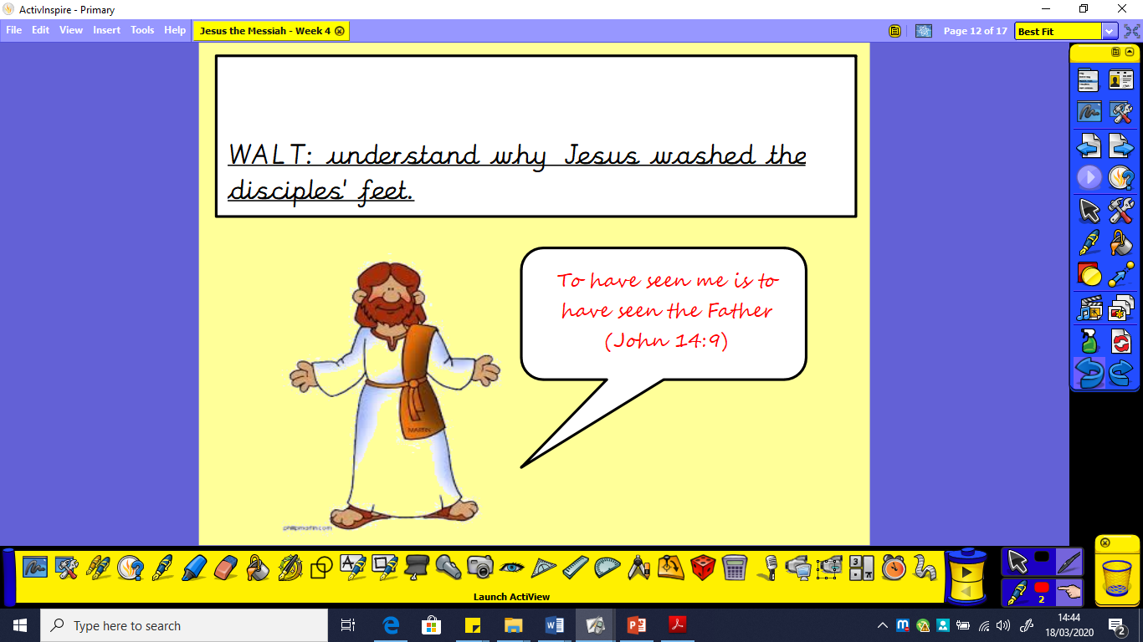

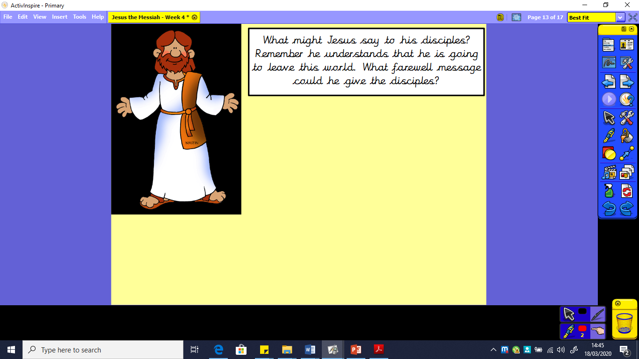

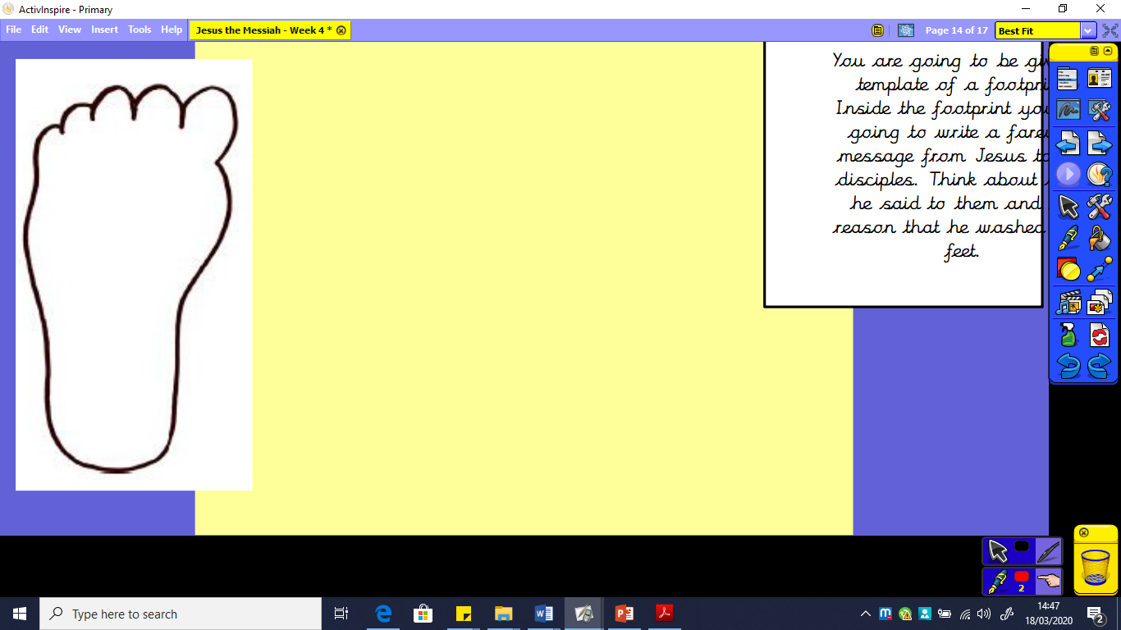

Draw an outline of a foot or print one off from the website. Inside, write a farewell message from Jesus to his disciples. Look at the WAGOLL (What a good one looks like!) on the next page to help you.

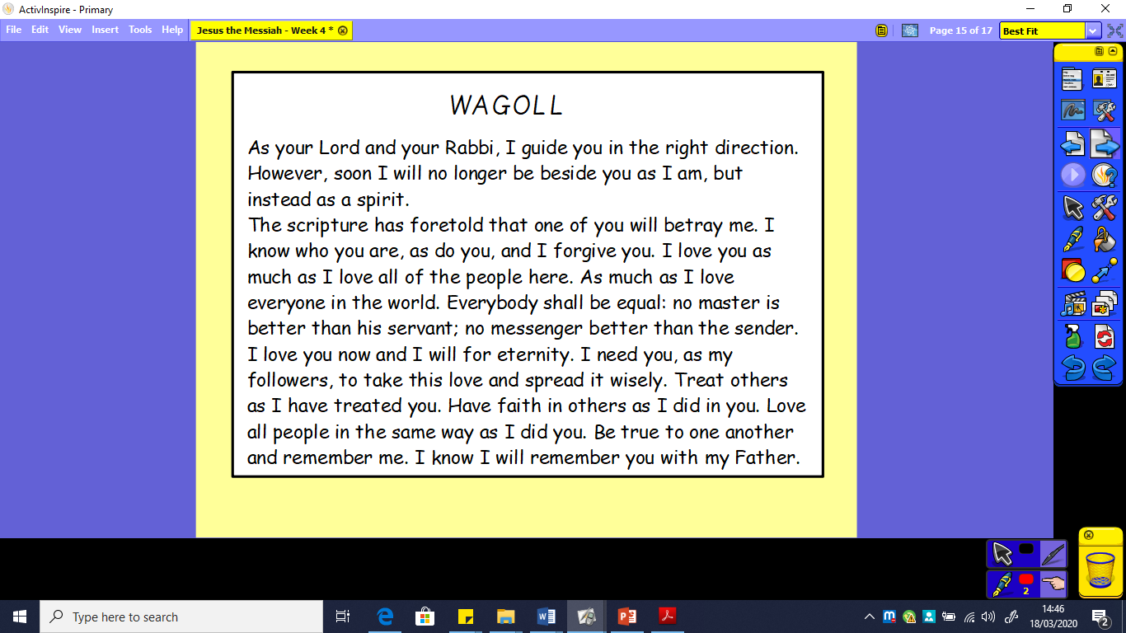

You could include the following:

* emotive language
* feelings of the writer
* a range of punctuation