Nursery Homework

W/B 9/3/20

Draw a fish with 3 spots. Colour each spot a different colour.

This week we have enjoyed reading *The Rainbow Fish.*

Use books or the internet to find out about a creature that live under the sea. We can then share our facts with the rest of the class!

The Rainbow Fish learnt to be a good friend. Talk to an adult at home about the different ways to be a good friend.

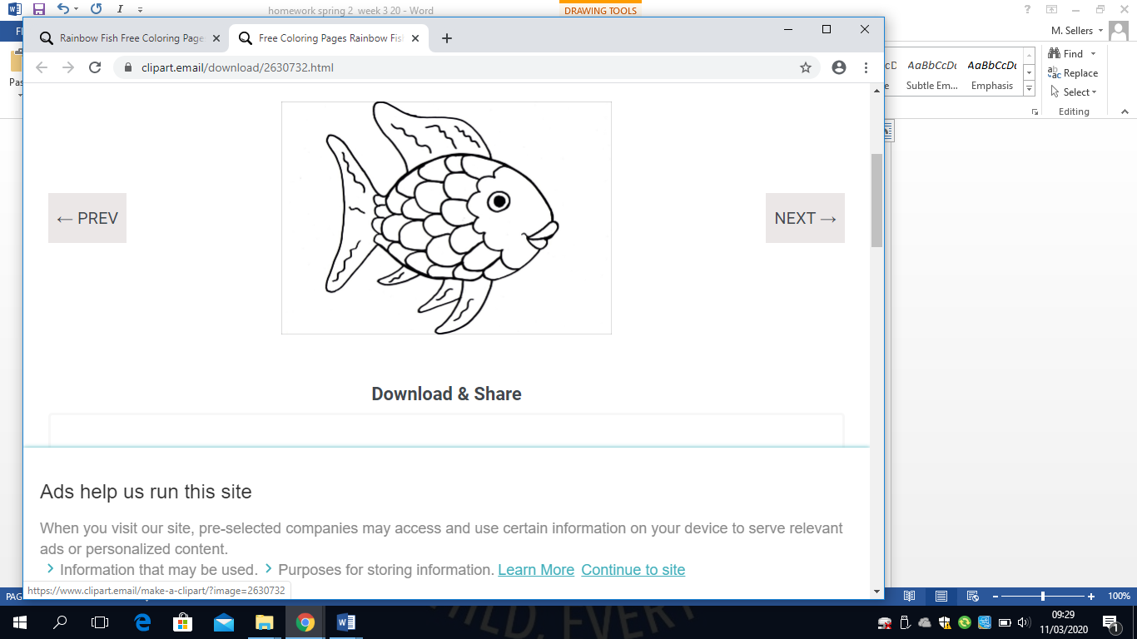

This week our Nursery Star of the Week is…

Greatness!

Greatness has done some fabulous work in PE. He has also been trying very hard at recognising numbers and counting. Greatness always gets on well with everyone. Well done Greatness!

