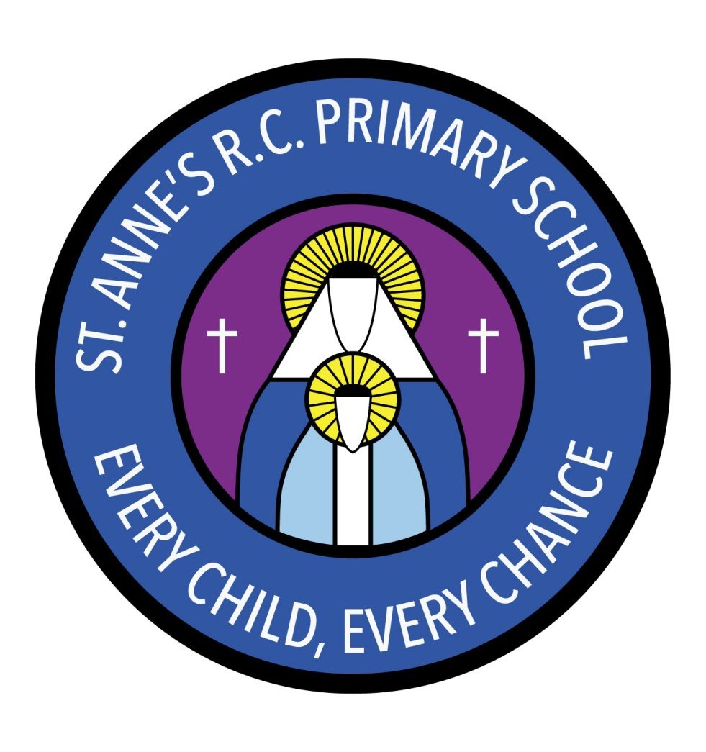
St Anne’s RC Primary School
Carruthers Street, Ancoats,
Manchester, M4 7EQ

Headteacher: Mrs A Shore
Deputy Head: Mrs J Greene

Dear Parents/Carers,
Happy New Year! We hope you had a lovely Christmas.
This half term our topics are Space and Superheroes.
In science we have been learning about the planets and made our own fizzing planets using baking soda and vinegar. We have also been learning about the craters on the moon. We had a go at making our own craters by dropping pebbles in a box of cornflour and investigated what made the biggest craters.
In maths we will be doing lots of counting and matching numeral to quantity. We will be comparing different amounts and saying which is more/less or the same. We will be learning that when you separate a set of objects in different ways the total stays the same. We will be also be learning about 2D shapes.
In RE our big question is “What and why do we celebrate?” We will be learning about different celebrations and the celebrations that take place in Church.
In PSHE we will be learning about inspirational people, pollution and also why we need rules.
In music our topic is ‘Working World.’ In this unit the children will be moving like robots, learning a song about robots and making sequences of sounds with combinations of metallic instruments in the robot song.
In PE we are doing gymnastics. We will be learning about travelling in different ways, stopping straightaway and making different shapes with our bodies.
If you have any questions or concerns please see a member of staff who will be able to make an appointment.
Thank you for your support.
Miss Sellers and Miss Muldoon

