Homework 16/1/20
Due 20/1/20
Spellings for test 23/1/20:  happiness  hardness  madness  nastiness  silliness  tidiness  childishness  willingness  carelessness  foolishness  Use each of your spellings in a sentence | Literacy  Answer the reading comprehension questions in your homework book.
Reading
Make sure you are reading regularly with a parent or carer at home and that your reading diary is being signed. Reading books and diaries should be in school every day.
Times Tables
Pick a times table to work on for our Multiplication and Division Masters test.
Maths
Remember Miss Tustain’s 3 steps:
- Multiply the whole number and the denominator together
- Add your answer from step 1 to the numerator
- Put your answer from question 2 on top of the old denominator
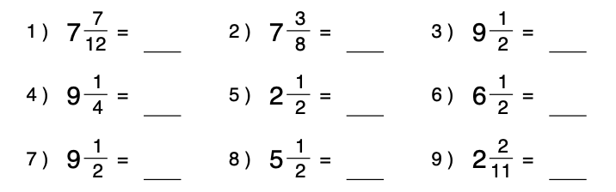

Homework 16/1/20
Due 20/1/20
Spellings for test 23/1/20:  happiness  hardness  madness  nastiness  silliness  tidiness  childishness  willingness  carelessness  foolishness  Use each of your spellings in a sentence | Literacy  Answer the reading comprehension questions in your homework book.
Reading
Make sure you are reading regularly with a parent or carer at home and that your reading diary is being signed. Reading books and diaries should be in school every day.
Times Tables
Pick a times table to work on for our Multiplication and Division Masters test.
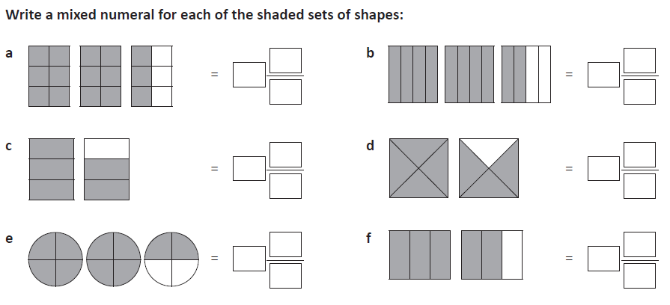
Maths

Homework 16/1/20
Due 20/1/20
Spellings for test 23/1/20:  Gardener  gardening  limited  limiting  offering  offered  Use each of your spellings in a sentence | Literacy  Answer the reading comprehension questions in your homework book.
Reading
Make sure you are reading regularly with a parent or carer at home and that your reading diary is being signed. Reading books and diaries should be in school every day.
Times Tables
Pick a times table to work on for our Multiplication and Division Masters test.
Maths

Remember Miss Tustain’s 3 steps:
- Multiply the whole number and the denominator together
- Add your answer from step 1 to the numerator
- Put your answer from question 2 on top of the old denominator

Homework 16/1/20
Due 20/1/20
Spellings for test 23/1/20:  Gardener  gardening  limited  limiting  offering  offered  Use each of your spellings in a sentence | Literacy  Answer the reading comprehension questions in your homework book.
Reading
Make sure you are reading regularly with a parent or carer at home and that your reading diary is being signed. Reading books and diaries should be in school every day.
Times Tables
Pick a times table to work on for our Multiplication and Division Masters test.
Maths

Homework 16/1/20
Due 20/1/20
Spellings:  car  start  park  arm  garden  artist  star  are  were  our | Reading  Make sure you are reading regularly with a parent or carer at home and that your reading diary is being signed. Reading books and diaries should be in school every day.
Maths

Remember Miss Tustain’s 3 steps:
- Multiply the whole number and the denominator together
- Add your answer from step 1 to the numerator
- Put your answer from question 2 on top of the old denominator

