Homework 9/1/20
Due 13/1/20
Spellings for test 16/1/20:  community  curiosity  ability  visibility  captivity  activity  eternity  flexibility  possibility  sensitivity  Use each of your spellings in a sentence | Literacy  Answer the reading comprehension questions in your homework book.
Reading
Make sure you are reading regularly with a parent or carer at home and that your reading diary is being signed. Reading books and diaries should be in school every day.
Times Tables
Pick a times table to work on for our Multiplication and Division Masters test.
Maths
Convert these improper fractions into mixed numbers.
Remember, firstly work out how many of the denominator are in the numerator. This is your whole number. Whatever you have left over is your fraction!
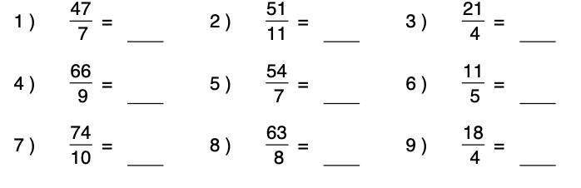

Homework 9/1/20
Due 13/1/20
Spellings for test 16/1/20:  community  curiosity  ability  visibility  captivity  activity  eternity  flexibility  possibility  sensitivity  Use each of your spellings in a sentence | Literacy  Answer the reading comprehension questions in your homework book.
Reading
Make sure you are reading regularly with a parent or carer at home and that your reading diary is being signed. Reading books and diaries should be in school every day.
Times Tables
Pick a times table to work on for our Multiplication and Division Masters test.
Maths

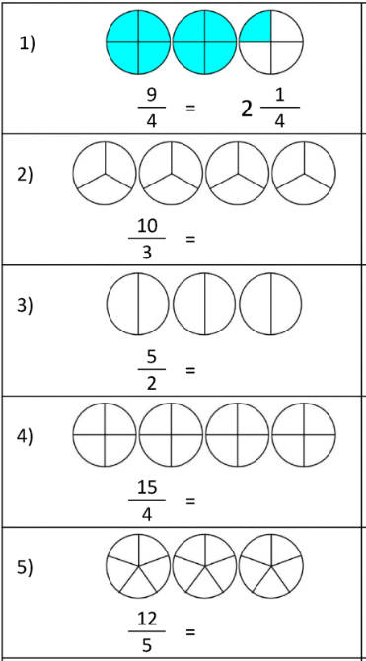
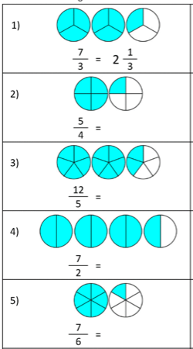

Homework 9/1/20
Due 13/1/20
Spellings for test 16/1/20:  myth  hymn  mystery  symbol  system  Use each of your spellings in a sentence | Literacy  Answer the reading comprehension questions in your homework book.
Reading
Make sure you are reading regularly with a parent or carer at home and that your reading diary is being signed. Reading books and diaries should be in school every day.
Times Tables
Pick a times table to work on for our Multiplication and Division Masters test.
Maths

Homework 9/1/20
Due 13/1/20
Spellings for test 16/1/20:  myth  hymn  mystery  symbol  system  Use each of your spellings in a sentence | Literacy  Answer the reading comprehension questions in your homework book.
Reading
Make sure you are reading regularly with a parent or carer at home and that your reading diary is being signed. Reading books and diaries should be in school every day.
Times Tables
Pick a times table to work on for our Multiplication and Division Masters test.
Maths
Convert these improper fractions into mixed numbers.
Remember, firstly work out how many of the denominator are in the numerator. This is your whole number. Whatever you have left over is your fraction!

Homework 9/1/20
Due 13/1/20
Spellings:  right  bright  light  night  fright  tight  high  I  by  my | Reading  Make sure you are reading regularly with a parent or carer at home and that your reading diary is being signed. Reading books and diaries should be in school every day.
Maths
Convert these improper fractions into mixed numbers.
Remember, firstly work out how many of the denominator are in the numerator. This is your whole number. Whatever you have left over is your fraction!

