A traditional tale | Read a book of poetry |  | Read a book someone has chosen for you |  | Read a book to someone else
 | A book with more than 10 pages | ST ANNE’S  READING CHALLENGE  AUTUMN 2  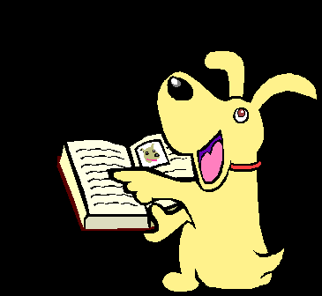 |  | Shakespeare
Read a book that was written before you were born | A mystery |  |  | A book about a famous person | Read a book that has chapters in
 | A comic |  |  | A non-fiction book
Read outdoors | A newspaper |  |  | Read a book that is a favourite of a relative | Read under the covers at bedtime

