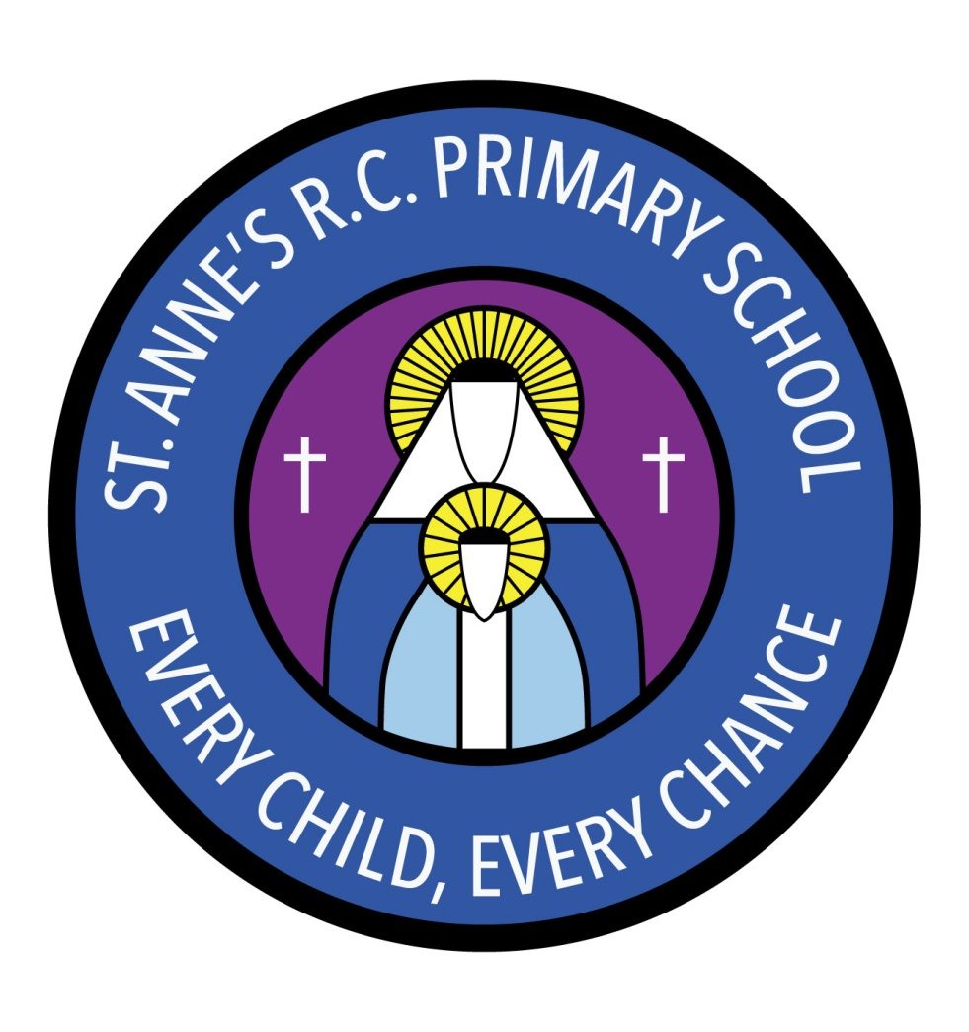
St Anne’s RC Primary School
Carruthers Street, Ancoats,
Manchester, M4 7EQ

Headteacher: Mrs A Shore
Deputy Head: Mrs J Greene

Dear Parents/Carers,
Welcome to another half term in Nursery!
It is essential that your child has a change of clothes in a bag on their peg. They will need a few skirts/trousers, a top, a few pairs of socks, a pair of shoes and a few pairs of underpants/knickers. If they do not have a change of clothing it may result in us having to phone you and for you to bring them down for us so we can change your child.
Please label everything! If your child loses an item that is not named it is so much more difficult to get it back.
This half term our topics are Teddy bears, Polar Regions and Christmas. We will also be busy practising our Christmas play.
In maths we will be doing lots of counting and number songs and matching numeral to quantity. We will be also learning about positional vocabulary and 2D shapes.
In RE our big question is “Why is welcome important?” We will be thinking about how we are welcomed into God’s family through baptism. We will also be learning about Advent and Christmas.
In PSHE we will be learning about how we can look after our environment by not dropping litter. We will also be thinking about how important it is to take responsibility.
In music our topic is ‘Growth and Change.’ In This unit the children will be exploring loud and quiet sounds. They will also be responding to a piece of music with hand and whole-body movements.
In PE through the topic Toys we will be exploring different movements for different toys.
If you have any questions or concerns please see a member of staff who will be able to make an appointment.
Thank you for your support.
Miss Sellers and Miss Muldoon

