Homework 7/11/19
Due 11/11/19
Spellings for test 14/11/19:  doubt  lamb  debt  thumb  solemn  autumn  column  knight  knuckle  knot  Use each of your spellings in a sentence | Literacy  Answer the reading comprehension questions in your homework book.
Reading
Make sure you are reading regularly with a parent or carer at home and that your reading diary is being signed. Reading books and diaries should be in school every day.
Times Tables
Pick a times table to work on for our Multiplication and Division Masters test.
Maths

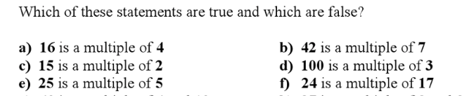
List 5 multiples of 6.

List 6 multiples of 8

List 7 multiples of 3

List the first 4 multiples of 15

Homework 7/11/19
Due 11/11/19
Spellings for test 14/11/19:  doubt  lamb  debt  thumb  solemn  autumn  column  knight  knuckle  knot  Use each of your spellings in a sentence | Literacy  Answer the reading comprehension questions in your homework book.
Reading
Make sure you are reading regularly with a parent or carer at home and that your reading diary is being signed. Reading books and diaries should be in school every day.
Times Tables
Pick a times table to work on for our Multiplication and Division Masters test.
Maths

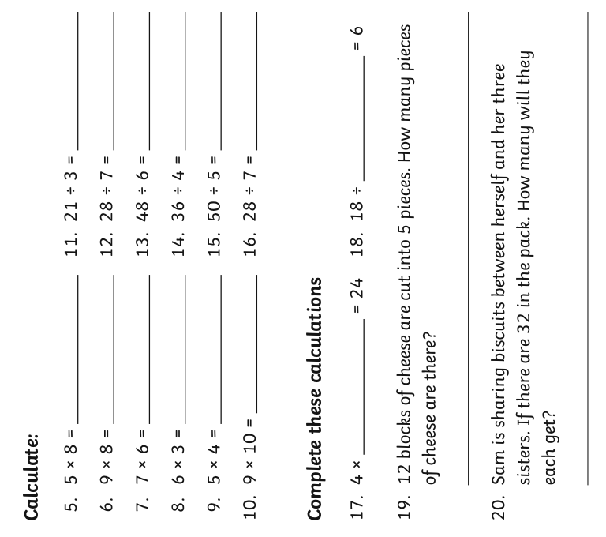

Homework 7/11/19
Due 11/11/19
Spellings for test 14/11/19:  kindly  quickly  safely  bravely  strongly  Use each of your spellings in a sentence | Literacy  Answer the reading comprehension questions in your homework book.
Reading
Make sure you are reading regularly with a parent or carer at home and that your reading diary is being signed. Reading books and diaries should be in school every day.
Times Tables
Pick a times table to work on for our Multiplication and Division Masters test.
Maths

List 7 multiples of 3

List the first 4 multiples of 15

List 5 multiples of 6.

List 6 multiples of 8

Homework 7/11/19
Due 11/11/19
Spellings for test 14/11/19:  kindly  quickly  safely  bravely  strongly  Use each of your spellings in a sentence | Literacy  Answer the reading comprehension questions in your homework book.
Reading
Make sure you are reading regularly with a parent or carer at home and that your reading diary is being signed. Reading books and diaries should be in school every day.
Times Tables
Pick a times table to work on for our Multiplication and Division Masters test.
Maths

Homework 3/10/19
Due 7/10/19
Use each word in a sentence:  Where  When  Why | Reading  Make sure you are reading regularly with a parent or carer at home and that your reading diary is being signed. Reading books and diaries should be in school every day.
Maths

