Reception Homework

W/B 30/9/19

In our topic sessions this week we have been thinking about PSHE and SMSC (personal, social, health and emotional and spiritual, moral, social and cultural).

We have been thinking especially about how we are all different and all special, and about how we manage our feelings. Can you talk about what makes you happy, sad, excited and angry?

Send a short video clip to us at [reception@st-annes-pri.manchester.sch.uk](mailto:reception@st-annes-pri.manchester.sch.uk) with your child’s name and the date as the subject.



This week we have been looking at comparing groups of objects and thinking about ‘more’ and ‘less’. We played a game where we held up some fingers and Mrs Mirza tried to find more… She tried her best, but she couldn’t beat Reception! Can you teach your grown up how to play? See if you can win!

Take a picture or a video and send it into us.

[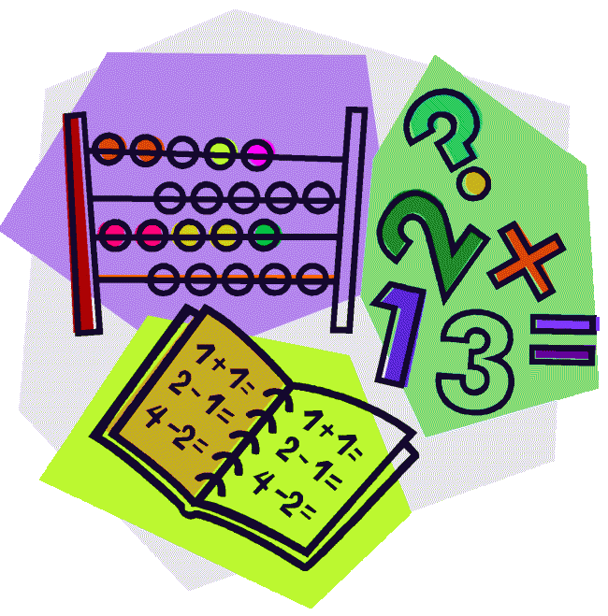](http://cheetahclass.files.wordpress.com/2013/11/numeracy.gif)

This week we have been working really hard on our phonics, especially listening for all of the sound in our words. We used slow motion talking to help us. Can you show your grown up how to do it? Try and put all of the sounds in the right order to match the pictures.

[](http://www.google.co.uk/url?sa=i&rct=j&q=&esrc=s&source=images&cd=&cad=rja&uact=8&docid=M5gmXQrAanB0dM&tbnid=JEtC_hATHEZr4M:&ved=0CAcQjRw&url=http://imgkid.com/someone-writing-clipart.shtml&ei=sG0YVMnmOYnvOpPUgcAD&psig=AFQjCNF_aceEKKd8KQ0wJA7ZrSEZCrIOFw&ust=1410973404907077)

Thank you so much for all of your donations and support for our MacMillan Coffee afternoon! The total is still rising, and we will let you know how much we raised next week.

Thank you for your continued support.

This week our Reception Star of the Week is…

Jeancy!

Jeancy has been a superstar this week. He has been working so hard on writing his name every morning. He was amazing at finding ‘more’ in the maths area and has been fantastic at slow motion talking in phonics to help hear all of the sounds in our words.

Well done Jeancy!

