ST ANNE’S Primary School

v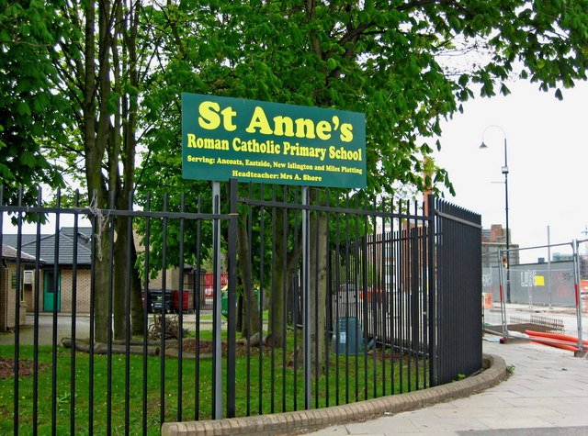St Anne`s is the best because we have a big playground.
St Anne`s is the best school because we do lots of fun things.

