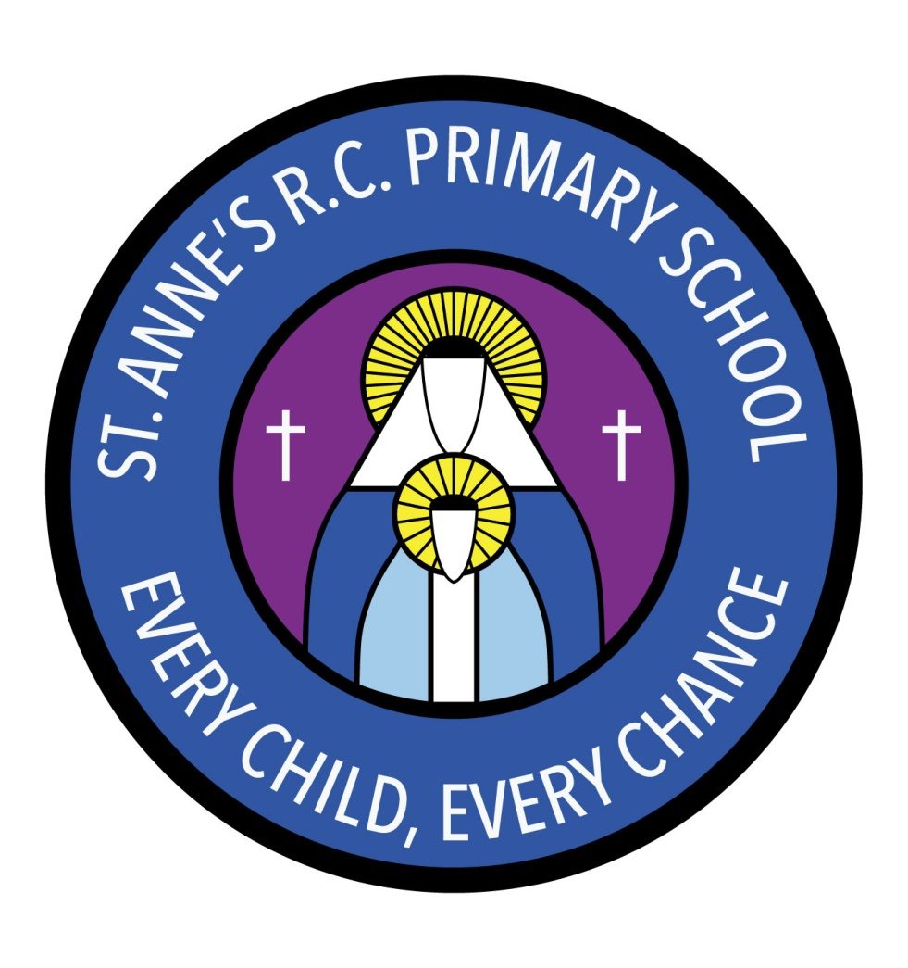
St Anne’s RC Primary School
Carruthers Street, Ancoats,
Manchester, M4 7EQ

Headteacher: Mrs A Shore
Deputy Head: Mrs J Greene

Dear Parents/Carers,
Welcome back. We hope you have had a good Easter.
This half term we will be learning about dinosaurs! We have a dinosaur land as our role play area now. We will be doing lots of fun activities for our topic such as searching for bones and fossils in the sand pit and finding out about the types of dinosaurs that were around in prehistoric times.
We discovered an egg in our classroom and quite a few of us think that there might be a baby dinosaur inside! We have written notices about looking after the egg. We will be writing about what we think is inside the egg and saying what we think will happen when the egg cracks.
In maths we will be learning about comparing numbers, addition and subtraction and one more and one less. We will also be learning about different shapes and measuring.
In RE our big question will be ‘Is it good to have friends?’ We will be thinking about what makes a good friend and how we show our friends that we care for them. Our other topic will be Hinduism.
In PSHE we will be learning about diversity in Britain. Another topic we will be covering is personal hygiene and how we keep ourselves clean and tidy and healthy.
In PE we will be doing a dance topic about the different seasons.
Our topic in music is moving patterns. We will be practising keeping the beat and also thinking about the structure of a piece of music. We will be moving to music and using body percussion to make up our own music.
Reading books and homework are given out every Thursday to be returned the following Tuesday.
If you have any concerns or questions, please don’t hesitate to speak to a member of staff who will be happy to make an appointment.
Thank you for your support.
The Nursery Team

