Homework 17/10/19
Due 21/10/19
Spellings for test 24/10/19:  accommodate  communicate  environment  parliament  government  sufficient  attached  sacrifice  vehicle  twelfth  Use each of your spellings in a sentence | Literacy  Answer the reading comprehension questions in your homework book.
Reading
Make sure you are reading regularly with a parent or carer at home and that your reading diary is being signed. Reading books and diaries should be in school every day.
Times Tables
Pick a times table to work on for our Multiplication and Division Masters test.
Maths
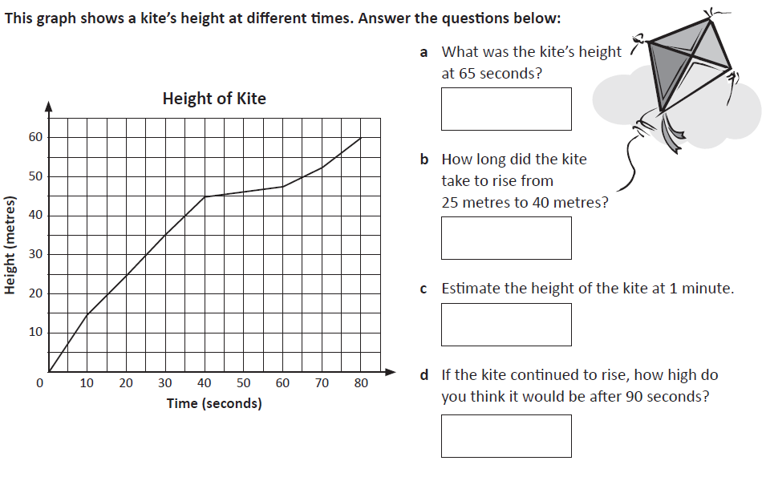
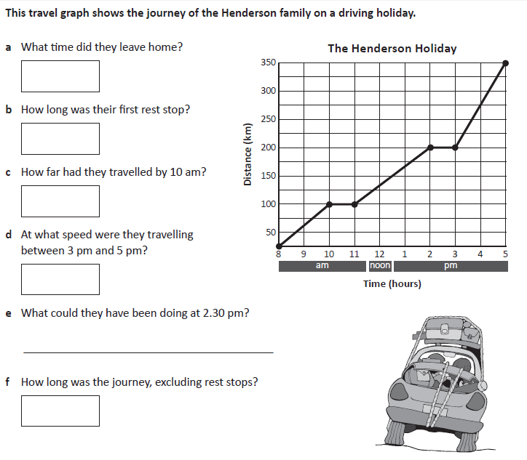

Homework 17/10/19
Due 21/10/19
Spellings for test 24/10/19:  accommodate  communicate  environment  parliament  government  sufficient  attached  sacrifice  vehicle  twelfth  Use each of your spellings in a sentence | Literacy  Answer the reading comprehension questions in your homework book.
Reading
Make sure you are reading regularly with a parent or carer at home and that your reading diary is being signed. Reading books and diaries should be in school every day.
Times Tables
Pick a times table to work on for our Multiplication and Division Masters test.
Maths

Homework 17/10/19
Due 21/10/19
Spellings for test 24/10/19:  sufficient  attached  sacrifice  vehicle  twelfth  Use each of your spellings in a sentence | Literacy  Answer the reading comprehension questions in your homework book.
Reading
Make sure you are reading regularly with a parent or carer at home and that your reading diary is being signed. Reading books and diaries should be in school every day.
Times Tables
Pick a times table to work on for our Multiplication and Division Masters test.
Maths

Homework 17/10/19
Due 21/10/19
Spellings for test 24/10/19:  when  with  where  were  wear  Use each of your spellings in a sentence | Literacy  Answer the reading comprehension questions in your homework book.
Reading
Make sure you are reading regularly with a parent or carer at home and that your reading diary is being signed. Reading books and diaries should be in school every day.
Times Tables
Pick a times table to work on for our Multiplication and Division Masters test.
Maths

Homework 17/10/19
Due 21/10/19
Spellings for test 24/10/19:  when  with  where  were  wear  Use each of your spellings in a sentence | Literacy  Answer the reading comprehension questions in your homework book.
Reading
Make sure you are reading regularly with a parent or carer at home and that your reading diary is being signed. Reading books and diaries should be in school every day.
Times Tables
Pick a times table to work on for our Multiplication and Division Masters test.
Maths

Homework 3/10/19
Due 7/10/19
Use each word in a sentence:  when  with  where  were  wear | Reading  Make sure you are reading regularly with a parent or carer at home and that your reading diary is being signed. Reading books and diaries should be in school every day.
Maths

