Reception Homework

W/B 22/4/19

We have been learning about keeping the beat in our music lessons. Can you choose a song to sing with your grown up and keep the beat? Remember you can tap your knees, clap your hands, stamp your feet – the possibilities are endless! Take a photo or a short video clip and send it to us at reception@st-annes-pri.manchester.sch.uk



This week we have been working on adding and counting on. It’s been really tricky! We’ve been using 2 dice to find 2 numbers to add together. We’ve been putting one number in our heads, and then jumping on to find the answer. Can you practice this at home? Ask your grown up to choose 2 numbers. Put one in your head and then add by counting on.

[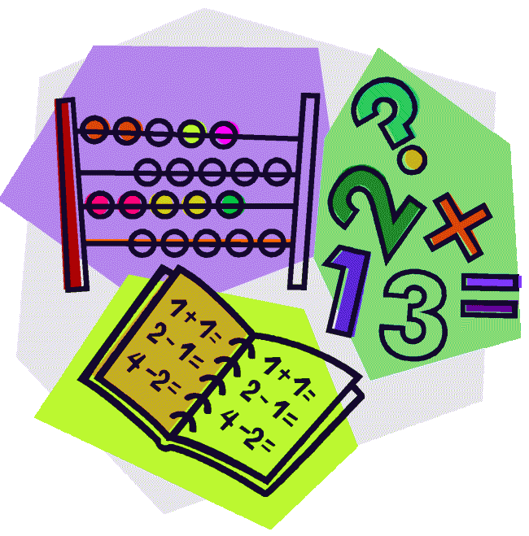](http://cheetahclass.files.wordpress.com/2013/11/numeracy.gif)

This week we have been learning all about Saint George. We have been reading about his battle with a dragon and how he saved a Princess! Can you find out any interesting facts about Saint George?

[](http://www.google.co.uk/url?sa=i&rct=j&q=&esrc=s&source=images&cd=&cad=rja&uact=8&docid=M5gmXQrAanB0dM&tbnid=JEtC_hATHEZr4M:&ved=0CAcQjRw&url=http://imgkid.com/someone-writing-clipart.shtml&ei=sG0YVMnmOYnvOpPUgcAD&psig=AFQjCNF_aceEKKd8KQ0wJA7ZrSEZCrIOFw&ust=1410973404907077)

Welcome back! We hope you had a lovely week off and had lots of fun in the sunshine.

Just a reminder that book bags are to be returned every Tuesday to be changed.

Rainbows! If you are interested in your daughter joining the local Rainbows group, please see the poster in the Reception window for details.

Thank you for your continued support.

This week our Reception Star of the Week is…

Emily!

Emily has been doing some fantastic work this week. She has been taking turns with her friends when we were playing games in the maths area and she did some wonderful writing about Saint George. She also did some amazing work in our music lesson. Well done Emily!

