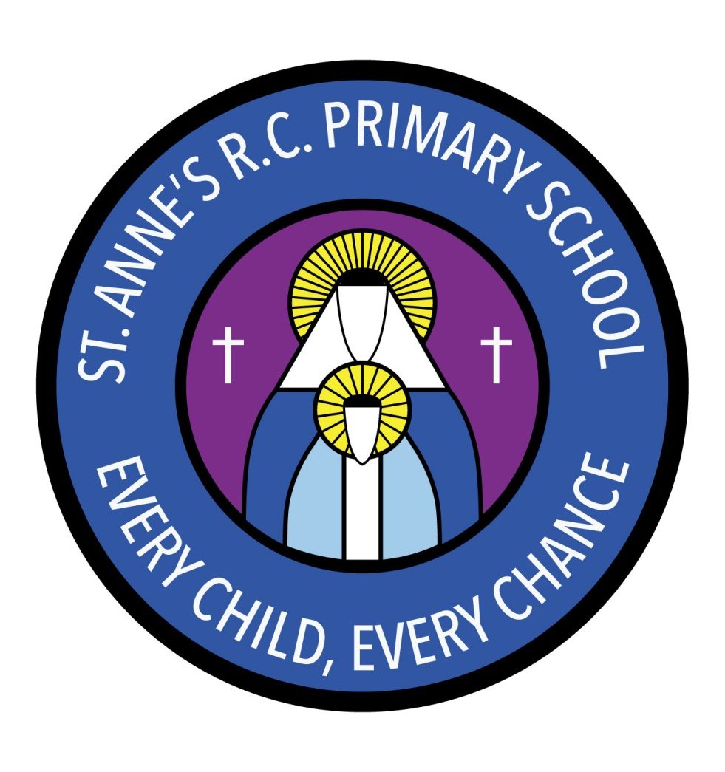
St Anne’s RC Primary School
Carruthers Street, Ancoats,
Manchester, M4 7EQ

Headteacher: Mrs A Shore
Deputy Head: Mrs J Greene

Spring 1 Half-Term

Dear Parents/Guardians Welcome back to Year 1 Homework will be given out on Thursdays and is to be handed in by the following Wednesday.
The children have been given some creative homework ideas going in line with our current topics, these can be found on our class homework page.
Spelling lists will also be given out on Thursdays and these will be tested on the following Thursday.
This half term the children in Year 1 will be looking at how to write non-fiction texts as well as character descriptions.
Whilst in maths, the children will be learning about place value, addition and subtraction as well as shapes.
In science we will be learning about properties of everyday materials.
As part of our History topic “The Great fire”, the children will be learning the Great Fire of London.
Can I also take this opportunity to remind everyone that P.E takes place on Tuesdays and Fridays, please ensure your child has a P.E kit on these days.
The P.E. kit your child is expected to bring is as follows:
• Black/dark blue shorts or jogging bottoms.
• Plain white t-shirt.
• Appropriate footwear for both indoor and outdoor P.E.

Thank you for your consideration Mr Moynihan (Year 1 teacher)

