Reception Homework

W/B 14/1/19

In maths this week we have been doing some work on time. We have been looking at our day from getting up to going to bed, and learning all about ‘o’clock’. Can you find out which ‘o’clock’ it is and write it down?

[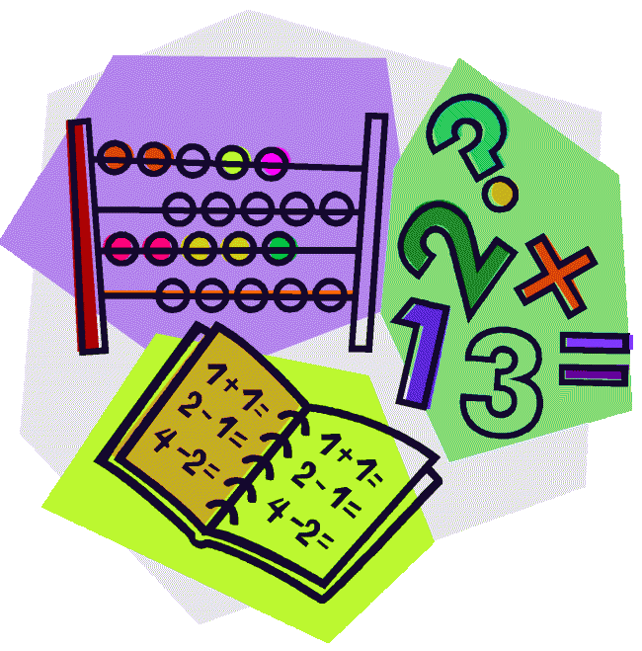](http://cheetahclass.files.wordpress.com/2013/11/numeracy.gif)

This week, we have started our new topic, looking at people who help us. This week, we have been looking at people who help us around our school. Think about who helps you at home. Can you make them a thank you card and send it to them?

[](http://www.google.co.uk/url?sa=i&rct=j&q=&esrc=s&source=images&cd=&cad=rja&uact=8&docid=M5gmXQrAanB0dM&tbnid=JEtC_hATHEZr4M:&ved=0CAcQjRw&url=http://imgkid.com/someone-writing-clipart.shtml&ei=sG0YVMnmOYnvOpPUgcAD&psig=AFQjCNF_aceEKKd8KQ0wJA7ZrSEZCrIOFw&ust=1410973404907077)

We need your help! We are trying to restock our junk modelling box. If you have any empty cardboard boxes, water bottles etc could you please bring them in and we will put them to good use. The possibilities are endless!

Next Friday (25th January), you are invited to our ‘Share a Book’ session. Please complete the slip on the letter and return it to school by the Wednesday 23rd.

Thank you for your continued support.

This week our Reception Star of the Week is…

Pola!

Pola made an amazing clock for our wall, and has been amazing us all with finding the right ‘o’clock’. She has also been working really hard in phonics, and has been using our phoneme frames to sound out her words. Well done Pola!



This half term we will be looking at lots of different people who help us, like doctors, nurses, policemen and women, and fire fighters. Can you draw a picture of someone who helps us for us to put on our wall?

