Reception Homework

W/B 29/10/18

This week we have been working really hard in our maths area, and getting a bit messy, too! We have been thinking about capacity. We have been looking at empty, half full, nearly full and full, and using porridge to help us investigate.

Can you colour in the bowls to show how much porridge is in each one?

(Much less mess than the real thing!)

[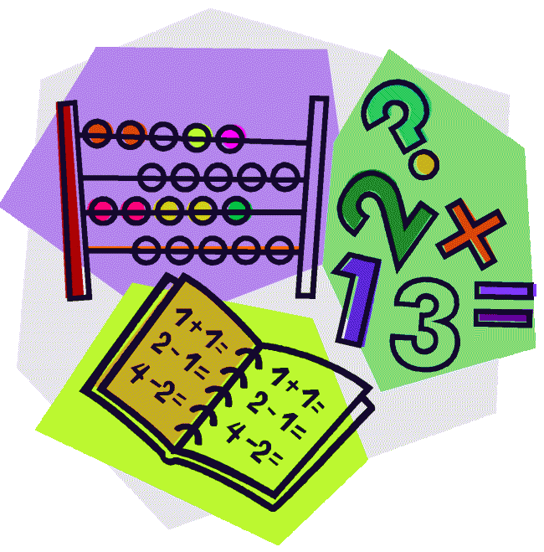](http://cheetahclass.files.wordpress.com/2013/11/numeracy.gif)

Our story this week has been Goldilocks and the Three Bears. The children have really enjoyed acting out the story, and have made their own stick puppets in the creative area. We also created our own story maps to help us remember the story. Can your child retell you the story, remembering some of the actions?[](http://www.google.co.uk/url?sa=i&rct=j&q=&esrc=s&source=images&cd=&cad=rja&uact=8&docid=M5gmXQrAanB0dM&tbnid=JEtC_hATHEZr4M:&ved=0CAcQjRw&url=http://imgkid.com/someone-writing-clipart.shtml&ei=sG0YVMnmOYnvOpPUgcAD&psig=AFQjCNF_aceEKKd8KQ0wJA7ZrSEZCrIOFw&ust=1410973404907077)

Next week we will be having a Teddy Bears’ Picnic. Please bring in a Teddy Bear from home on Friday 9th November.

Also next week, we will be learning about Remembrance Day. On Thursday 8th November we will be having a soldier in uniform visit our class. If you have any questions, please speak to a member of staff.

Thank you for your continued support.

This week our Reception Star of the Week is…

Vicky!

Vicky has been trying so hard this week. She has been retelling the story of Goldilocks, and wrote an amazing letter to the Three Bears. She has been doing lots of work in the maths area and has been talking about empty and full. Well done Vicky!



Our story this week led us to become builders! We have been designing chairs in the construction area, before making them using different materials. Can you use things you have at home to make Baby Bear a new chair?

