Reception Homework
W/B 1/10/18

This half term our topic is ‘All About Me.’ So far, we have been looking at ourselves, our bodies and our families. This week we have been thinking about our senses and which parts of our bodies we use for each sense.

This week we have been using our senses. We have been sense detectives! We have tried to find out what some hidden items were by using our 5 senses. This week, you could go on a sense walk with your child. What can you see, hear, smell, taste and touch?

In maths this week, we have been looking at shapes and their properties. We have been looking at how many sides shapes have, and if they are straight or curved.
We have really enjoyed searching for shapes around our classroom, and even found some outside! This week, you could look for some shapes in your house and take photographs or draw them for us to display in our classroom.
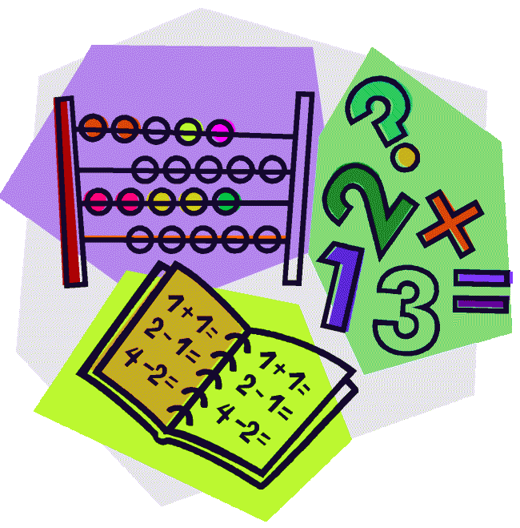

This week, please share a story with your child and return their reading book on Thursday.

This week our Reception Star of the Week is…
Joel!
Joel has impressed everyone this week with his literacy and his phonics. He has been working really hard to use his robot arms to sound out words when he has been doing his writing. Well done Joel!

